 | 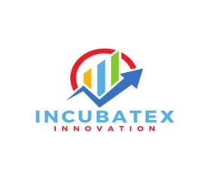 | 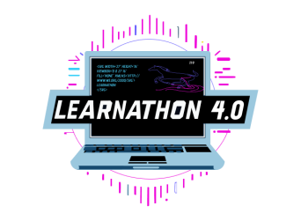 |  | 

LEARNATHON 4.0
Unlocking the future: Learn, Build, Innovate
Learn to Hack - Hack to Learn
Artificial Intelligence & Machine Learning
(23rd July-26th July 2025)

Organized by
GIET University, Gunupur-765022
In association with
COIGNITE EDUTECH SERVICES PVT LTD
Jury Members
S/No. | Day | Date | Internal Jury | Physical Jury Members from Industry | Online
1 | Wednesday | 23/07/2025 | Dr.Premansu Sekhar Rath (CSE) | Mr. Vikrant Shitole, Head of Traning, CO-IGNITE
1 | Wednesday | 23/07/2025 | Mr. Jagadish Sahoo (CSE) |  | Kalpana Sastry , Former MD-AGHUB  (Online)
2 | Thursday | 24/07/2025 | Dr. Nilamdhab Padhy (CSE) | Dr Kushwanth Kumar S ,  Scientist-C  AIC-AMTZ MediValleyv
2 | Thursday | 24/07/2025 | Dr. Priyadarsan Parida (ECE) | Dr S Suryanarayana Raju D,Assistant Professor in CSE (AI and ML)
3 | Friday | 25/07/2025 | Dr. A.V S Pavan Kumar (CSE) | Dr. Gundala Naga Raju,CEOSmartmeiten
3 | Friday | 25/07/2025 | Dr. Pratap Kumar Panigrahi (EEE) | Sonia Govindarajulu , Data Analyst
Dr. NVJ Rao
Registrar
GIET University

