 | 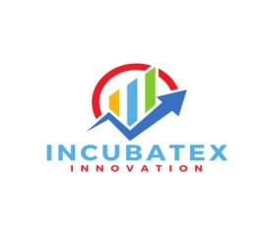 | 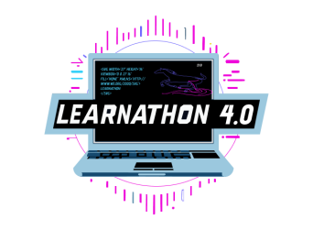 |  | 
LEARNATHON 4.0
Unlocking the future: Learn, Build, Innovate
Learn to Hack - Hack to Learn
Artificial Intelligence & Machine Learning
(23rd July-26th July 2025)
Organized by
GIET University, Gunupur-765022
In association with
COIGNITE EDUTECH SERVICES PVT LTD
Judging Parameters for LEARNATHON 4.0
S/No. | Team name | Problem Understanding (10) | Innovation & Creativity (15) | Technical Implementation (15) | Functionality & Working Demo (10) | AI/ML Integration(10) | User Interface & Design (UI/UX) (10) | Team Collaboration & Role Distribution(10) | Presentation & Communication Skills(10) | Scalability & Real-world Impact(10) | Total (100)
1
2
3
4
5
6
7
8
9
10

Dr. NVJ Rao
Registrar, GIET University

