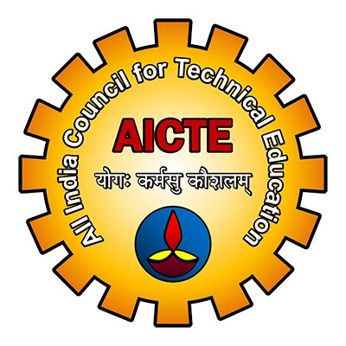 |  | 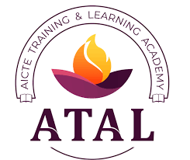

Online AICTE Training and Learning (ATAL)
Faculty Development Programme (FDP) on
Recent Advances in Artificial Intelligence
[22nd to 26th February 2022]

Organised by:
Department of Computer Science and Engineering
School of Engineering and Technology
GIET University, Gunupur-765022

Online Meeting Platform: Google Meet

INAUGURAL SCHEDULE

 | Date: 22nd February 2022 (Tuesday)
Time | Event
09:00AM-09:05AM | Joining of online inaugural session by  Session Speakers and Participants
09:05AM-09:10AM | Welcome Address by Head of the Department (CSE)  Dr. Sanjay Kumar Kuanar
09:10AM-09:15AM | Address by Vice Chancellor  Dr. Gautam Ghosh, Vice Chancellor, GIET University, India
09:15AM-09:20AM | Address by Special Guest  Dr. Siba K. Udgata, Professor, School of Computer and Information Sciences, University of Hyderabad, India
09:20AM-09:30AM | Address by Chief Guest  Col. B. Venkat, Director (FDC), AICTE, New Delhi
09:30AM-09:35AM | Vote of Thanks by Co-Convenor  Dr. Brojo Kishore Mishra

*Google Meet Link:: meet.google.com/nja-vxzy-res

